DIRECT DEPOSIT AUTHORIZATION FORM

Please print and complete ALL the information below.

Name: ___________________________________________________________

Address: ___________________________________________________________

City, State, Zip: _____________________________________________________

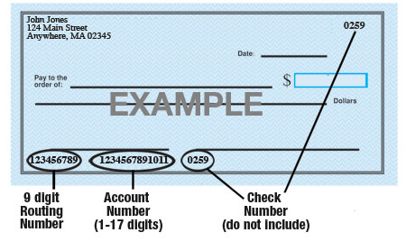

Name of Bank: _____________________________________________________

Account #: _____________________________________________________

9-Digit Routing #: _____________________________________________________

Amount: ◻ Entire Paycheck OR ◻ $ ________ ◻ ________%

Type of Account: ◻ Checking ◻ Savings

Please attach a voided check for each bank account to which funds should be deposited.

I authorize, ___________________________ [Company or Organization] to directly deposit my pay to the account listed above. This authorization will remain in effect until I modify or cancel it in writing.

Employee Signature: ____________________________ Date: ___________________

Print Name: ____________________________

